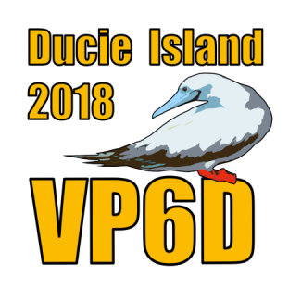

VP6D Ducie Island 2018 DX-pedition
Dave Lloyd K3EL, Gene Spinelli K5GS

Introduction to Ducie Island
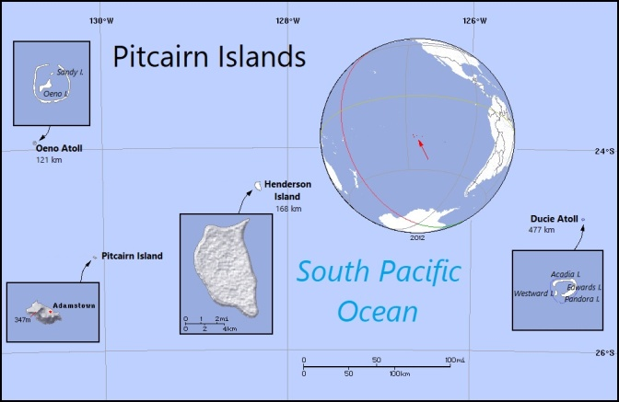
Ducie Island is an uninhabited atoll in the Pitcairn Island group located in the center of the southern Pacific Ocean approximately equidistant from Chile and New Zealand, both several thousand kilometers away. It lies 535 kilometers (332 mi) east of Pitcairn Island, and over 1,000 km west of Easter Island. The atoll is 2.4 km (1.5 miles) long, measured northeast to southwest, and about 1.6 km (1 mile) wide. We landed on the main island, Acadia, on the north and east side of the atoll. Acadia is crescent-shaped, several hundred meters long and mostly covered in low trees. There are also three small islets, Pandora, Westward and Edwards, on the southern side of the atoll. Due to its inaccessibility and landing permit requirements, Ducie is rarely visited today.
Figure 1. Pitcairn Islands Location (stampaday.wordpress.com image)
Amongst the Pitcairn group, Henderson Island is most famous for its birds, but Ducie is also a significant breeding ground for a number of species. More than 90% of the world population of Murphy's petrel nests on Ducie (an estimated 250,000 birds), while pairs of red-tailed tropicbirds and fairy terns make around 1% of the world population for each species.
Ducie was first discovered in 1606 by Pedro Fernandes de Queirós, who named it Luna Puesta, and rediscovered by Edward Edwards, captain of HMS Pandora, who was sent in 1790 to capture the mutineers of HMS Bounty (although they did not find the mutineers on nearby Pitcairn). Edwards named the island Ducie in honor of Francis Reynolds-Moreton, 3rd Baron Ducie, under whom he had previously served. In 1867 it was claimed by the United States under the Guano Islands Act, but the United Kingdom annexed it on 19 December 1902 as part of the Pitcairn Islands.
Ducie became a DXCC entity on November 16, 2001, after the Pitcairn Island Amateur Radio Association (PIARA) was accepted as an International Amateur Radio Union member-society. The first expedition was led by Kan, JA1BK in March 2002 using the VP6DI call sign. One year later, Ducie was again on the air with VP6DIA. Ducie was last activated in Feb 2008 as VP6DX by an international team of 13 operators, who made over 180,000 contacts in 16 days of operation. However, after 10 years of no amateur radio activity, Ducie had been climbing up the most-wanted lists and was ranked as ClubLog’s #19 before VP6D’s activation.

Planning and Preparation
At the 2017 International DX Convention at Visalia, California, members of the Perseverance DX Group (PDXG) discussed several potential DX-pedition opportunities, and we quickly decided upon Ducie as our next target. It was clear that there would be plenty of interest since the island had not been activated for a decade, so anyone licensed or taking up DXing since 2008 would not yet have had a chance to work Ducie. Also, the island is well-positioned for propagation to all major centers of amateur radio activity, so we expected to be able to work even modestly-equipped stations. The potential to make a large number of contacts drove the design of our expedition. At the bottom of the solar cycle, only a few bands would be open at any one time, so we set up two camps (one with a CW focus, the other primarily SSB, although we operated digital modes from both locations) distant from each other to allow two stations to operate simultaneously on a band when it was open, with a complete set of antennas at each camp to provide maximum operating flexibility.
Ducie proved to be a popular choice and the operating team was quickly filled. Our international team included: Dave K3EL, Les W2LK, Gene K5GS as Team Leader and Co Team Leaders, respectively, Heye DJ9RR, Mike WA6O, Vadym UT6UD, Steve W1SRD, Walt N6XG, Laci HA0NAR, Jacky ZL3CW, Chris N6WM, Arnie N6HC, Rob N7QT and Ricardo PY2PT. Many of the team members knew one another from previous PDXG or other DX-peditions or had met at ham radio events. We held several pre-expedition teleconferences to help the team gel, dealing with topics such antenna planning, operator scheduling, travel planning, and the thousand-and-one other details that must be decided before the team sets out. The detailed plans were documented in the VP6D Operations Manual which was shared with everyone prior to departure.
Landing on Ducie Island for a DX-pedition and overnight stays requires a landing permit (issued by the Police and Immigration Office on Pitcairn Island), a travel visa and a VP6/D radio license. Shortly after the DX convention we applied for the landing permit. The application included our plan for 14 operators, tents, generators, radio stations and various antenna types. We received the permit in July, 2017 and immediately applied for the VP6D call sign and travel visas which were issued soon after.
We selected the expedition ship Braveheart from Tauranga, New Zealand. Braveheart, and her owner Nigel Jolly, K6NRJ, have a long history of providing outstanding support to the DX-pedition community. Nigel’s son Matt was the skipper for this project, and his younger son Dan was a crewmember.

Travel and Set-Up
During the weekend of Oct. 13th the radio operators met in Papeete, Tahiti. From Papeete we flew to Mangareva, the easternmost major island in French Polynesia where Braveheart was waiting, our equipment having previously been loaded aboard in New Zealand. Mangareva is a no-frills stop in French Polynesia with just a few cafes and several small shops set up in residents’ homes to sell supplies to locals and to the yachting community. Mangareva’s primary source of income is Black Pearl farming.
We departed Mangareva on Oct 16th for the journey to Ducie. By the use of social media and a Garmin personal locator many of you (and our families) followed our progress across the Pacific. Seas were calm and the winds helpful, so we arrived at Ducie 12 hours earlier than planned and were able to begin transferring people and equipment to Ducie the morning of Friday, Oct 19th. All radio and campsite equipment was ferried ashore using the Braveheart’s rigid inflatable boats. The Braveheart crew, with assistance from the radio operators, established campsites complete with kitchen, covered eating area, large rectangular frame tents for the radios, and sleeping tents. The sleeping tents each housed three people, with a camp cot for each person.
Much of Ducie is heavily wooded with Heliotropium foertherianum, so the tents were put up in-between or underneath the trees which provided excellent shelter from the strong winds so we had no problems with tents being blown down. Meals were prepared on the island by the Braveheart crewmembers who stayed ashore with the radio team. They prepared three meals a day, replenishing their food stocks from Braveheart as required. A camp toilet was dug and a camp shower constructed. Each team member was allocated enough fresh water for one shower a day, plus all the drinking water they required. To get clean you could also swim in the lagoon or the sea during daylight hours, but at night sharks prowled the shallow waters.
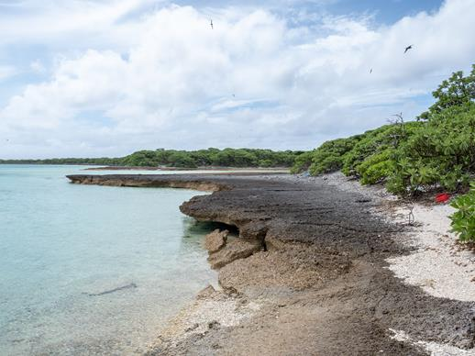
We established two camps, the SSB/Headquarters/main sleeping and eating area on the eastern side of the island and the CW camp just over a kilometer away on Ducie’s north coast. There were only a few possible landing sites because a fringing reef surrounds most of the shore, so these determined the locations of the two camps. The separation of about 1 km was adequate to eliminate radio interference between the camps, although the distance between the sites presented some challenges. The ocean shore on Ducie is made of coral rubble which is tiring to walk on, so this was not a good choice for commuting between the two camps. The dense brush made walking directly between the camps impossible. The preferred route was to cut across the island from oceanside to lagoon, then walk along the shore of the lagoon before returning back across the island to the CW operating site. Even this route was rough, traversing sharp coral shelves and boulders that were at times submerged by the tide, but it was preferable to the alternatives. Once people got to know the route, it took 15 minutes or so to go from one camp to the other.
Figure 2. Path to CW Camp (K3EL Photo)
We were well-supported by various manufacturers and distributors of radio equipment, who provided the following items: Elecraft loaned eight K3S transceivers, KPA-500 amplifiers and P3 panadapters; DX Engineering coax, connectors, tools, antenna parts and misc items; SteppIR two-element Yagis; Rig Expert two AA-55 Zoom antenna analyzers, and Arlan Communications their RadioSport headsets. Spiderbeam provided a substantial discount on the fiberglass masts which we used to build many of the antennas. We had several SPE and OM Power amplifiers loaned by team members. Computers for logging were loaned by Bob KK6EK, and by a team member. Many of the Pelican and other shipping cases were provided by Paul N6PSE (Intrepid DX Group), Bob KK6EK and Jim K8JRK.
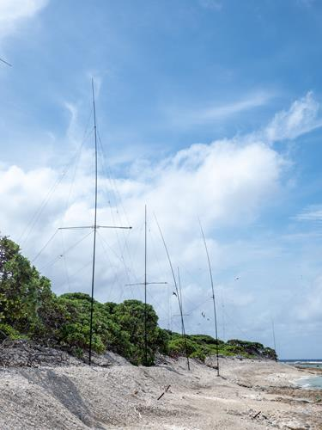
Much of Acadia Island is around 10 feet above sea level, with a steep drop off to the shore. The take-off is over water in the direction of NA and EU. For JA the take-off was along the shoreline from the SSB camp but there was a clear shot across the water from the CW camp on the northern shore. Because of the layout of the island, Ducie is an ideal location to use vertical antennas, located just at the edge of the drop off to the sea. Our antenna complement included home-made two-element vertical dipole arrays (VDAs) for the high bands at both sites, four-squares on 40 at the CW and SSB camps, a 30m four-square at the CW camp and a single 30m vertical for digital operations at the SSB location.
Figure 3. VDAs on shore (K3EL Photo)
For 80m we had a quarter-wave vertical and for 160m an inverted-L vertical. A Beverage helped out for low-bands receive. Also at the SSB camp was a 2 element SteppIR horizontal Yagi. A 6m EME Yagi antenna loaned by Lance, W7GJ, was located near the water’s edge along with the VDAs near the SSB camp. The Headquarters tent contained two BGAN satellite terminals used for uploading logs, DXA feed and receiving pilot reports. A WiFi link connected the CW camp to the Headquarters tent.

Radio Operations
Radio operations started during the night at 0416 UTC on 20th Oct with a couple of stations on the air. The next morning, the entire team returned to work completing the antennas and camps before full operation started the next day from both camps. We were delighted to find excellent propagation and strong signals worldwide. Later during the expedition the conditions dropped off a little but overall we could have few complaints about propagation. During periods of good propagation all eight stations were in action. As propagation waned during the night some of the SSB operations would shift to FT8, where a single operator could handle two or three FT8 stations simultaneously, then as sunrise approached the bands would become active again. One important element of planning for VP6D was scheduling, and we used an approach that had been successful on Heard Island VK0EK; we scheduled operators for four or five stations, depending on expected band activity, while the remaining stations were open for any other team member to use. The scheduled ops worked with designated team leaders to decide which bands/modes to use, and had priority during their operating shift. Operators coming to any of the remaining free stations could choose to do whatever they wanted, so long as the band/mode was not already occupied by a scheduled operator. This design ensured that all ops had a significant base amount of operating time, while providing an opportunity of extra time on-the-air for those who wanted it.
Each morning we’d look at the N1MM+ graphs and see that we were making ~10,000 QSOs a day. Signals from all over the world were strong. Pilot reports and over the air reports told us we were being heard without much difficulty on most bands, with the exception of 10/12 which were closed most of the time. Despite the low sunspot number, VP6D logged over 112,000 QSOs with just under 25,000 unique call signs: 53% NA, 26.6% EU and 15.8% AS. Firsts from Ducie Island were 28 6m EME contacts and 24,400 FT8 contacts. A couple of our team are enthusiastic RTTY operators so we made nearly 6,000 contacts by this mode. Still, it is clear from the numbers that FT8 was our primary digital mode. We had advertised the WSJT-X software version (1.9.1) and the fox/hound operating style we would employ, and for the most part callers followed the instructions on our website. However, a fair number of callers didn’t get the message straight away and were calling below 1000 Hz. This seemed to improve as time went on, as more people got the hang of fox/hound operation. It was interesting to see the popularity of FT8 not just amongst the callers, but also amongst the DX-pedition operators; perhaps the chance to remove the headphones and relax a bit was an occasional welcome break from the adrenaline rush of working a pileup on the other modes. 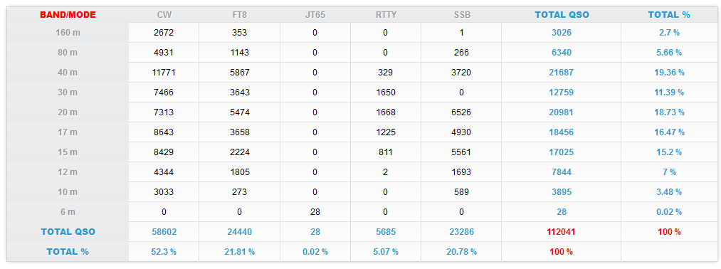

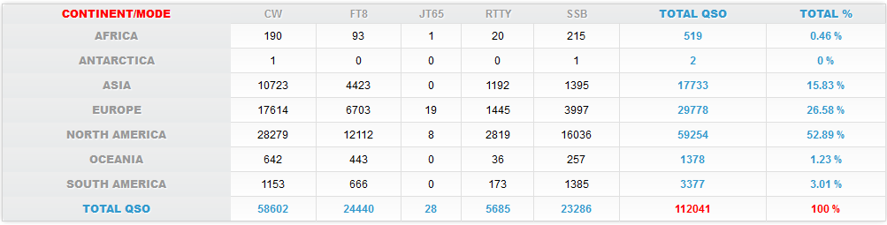
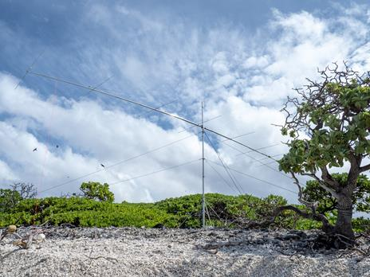
The EME operation was an interesting venture for us, since there was almost no EME experience within the team. However, we were given guidance by Lance, W7GJ, and by using his loaned EME antenna and “expedition procedure” we were able to make several QSOs on most nights. EME activity was limited to moonrise only because of the location of the antenna, and other competing operating activities.
We used DXA to provide real-time acknowledgement of contacts made, and QSOs were also uploaded to the PDXG on-line log, which is the basis for our OQRS system. These operations were not as smooth as we had hoped due to challenges of building a robust network across the island (which was achieved after a couple of days experimentation) and some incompatibilities between N1MM+ and WSJT-X which resulted in some contacts not making it to the N1MM+ log while on island, requiring resolution after the expedition.
Figure 4. 6m EME Antenna (K3EL Photo)

Departure
On about Oct 30th the skipper informed us of worsening sea conditions with increasing onshore winds and a significant swell building from a storm system that had passed to the south. Since Ducie has no natural harbor you are very dependent on favorable tide and sea conditions to safely leave the island. We began removing non-essential equipment a couple of days before the planned departure. Over the next two days we dismantled all campsites and antennas. The extraction process was exciting for all involved. Team members, assisted by the boat crew, walked two at a time through the surf on a slippery coral base to the edge of the reef where the zodiac could meet us. The skipper brought the zodiac in and people were “helped” one at a time into the zodiac as it came in on a wave, then the skipper quickly leaned on the throttle to get away from the coral, before maneuvering back for the next passenger. It was an exciting exit, but the next morning’s activities were even livelier when four team members returned to the island to help the crew recover the remaining equipment that had stayed on the beach overnight. By that time the wind had picked up significantly and the exhilarating experience of landing, loading and returning was one which we will remember for a long time.
After everyone and everything was safely aboard we began a 36 hour journey to Pitcairn Island. We were met by the island residents who transferred us from Braveheart to a longboat for the 30 minute exciting and wet ride to Bounty Bay. There we were greeted by the Pitcairn Island Police and Immigration officials who processed our arrival and stamped our passports. The team had an opportunity to have a look around the island, and meet some of the residents including several who had amateur radio licenses. It was then time to re-board the longboat for the ride back to Braveheart.
We arrived at Mangareva 36 hours later. The Braveheart the crew treated us to a BBQ on the fantail the night before our departure. The next morning we moved our personal gear to the wharf while the crew prepared Braveheart to receive their next clients, a group of bird watching enthusiasts. We then took a ferry to the airport for the once-a-week four hour flight to Tahiti.

Reflections
Back in Tahiti we had some time to finally relax and look back over the past three weeks. The consensus was that VP6D had been a great expedition for the island participants, and we hope it was also a good experience for those of you chasing us in the pileups. We have certainly enjoyed hearing from people who contacted us, be they mega-stations looking for a full house, or a temporary QRP setup on a beach looking for one QSO. A consistent theme from many who wrote to us was they had “fun” working VP6D, and we had fun working you.
Wrap Up
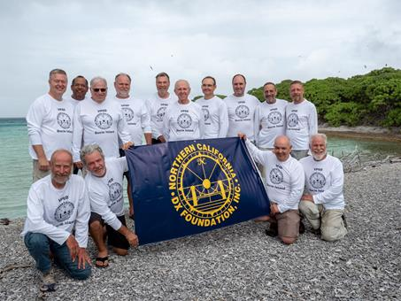
We would like to acknowledge the help and support of many groups and individuals who contributed to Ducie 2018. Major early sponsorship from organizations like the Northern California DX Foundation (NCDXF) and the German DX Foundation (GDXF) was important to kick-start our fundraising, and many other clubs and foundations also joined in supporting us. Please review the list of Corporate and Club / Foundation sponsors at VP6D.com, they deserve your support. Over 1,500 individual donors contributed via the VP6D website, including 74 premier donors (contributing over $200) and another 1,700 have added a contribution to their OQRS confirmation request since the expedition. As listed earlier, amateur radio manufacturers generously gave or loaned equipment. The on-island team were supported by many individuals, and in particular we would like to recognize our Chief Pilot Glenn, KE4KY, and his team of pilots, and also Pista, HA5AO who supports the PDXG websites and the OQRS / QSL system. And of course, Tim M0URX who processes / mails your QSL cards and uploads your LoTW confirmations.
Figure 5. VP6D Team at the Lagoon (K3EL Photo)

Among the highlights of the project were giving many DXers an ATNO and/or band fills, putting people on the Honor Roll, logging the first EME and FT8 contacts from Ducie Island, and working with a fantastic team of radio operators. We must also recognize Matt Jolly and his Braveheart crew who were as much a part of the project’s success as the radio team.

Until the next time, thank you for your interest in VP6D Ducie Island 2018.

